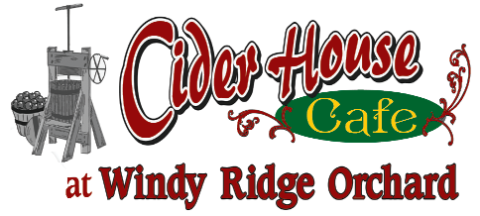

Milk – 2.50
Coffee (12 oz) 2.75
Soda – 1.00
Slushie - 4.00

Cider Donuts

Single 1.00
Half Dozen $6.00
Dozen $11.00
Served all day or until we run out!
Apple Crisp

$5.00

With Ice Cream $ 6.00
Pie

$5.00

With Ice Cream $ 6.00
All orders are subject to NH’s 9% meals tax
I’m sorry but we cannot accept credit cards but cash and checks work just fine!

